**Mock API Assignment**

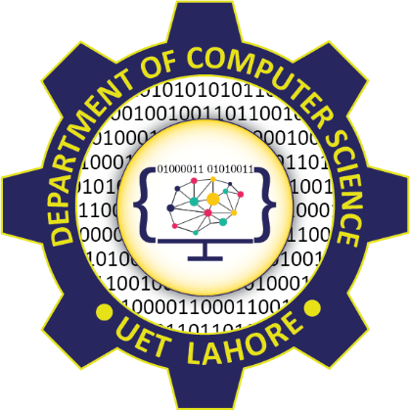

Session: 2021 – 2024

**Submitted by:**

Uswa Arif

2021-CS-77

**Submitted To:**

  Aatif Hussain

Department of Computer Science

**University of Engineering and Technology**

**Lahore Pakistan**

**Introduction:**

**API:**

APIs (Application Programming Interface) enable seamless data communication among software applications and digital services. The API providers impose certain access restrictions to their APIs. To resolve such challenges, a technique is used called **API mocking**, which basically involves creating a simulated version of the real API.

**Mocking API:**

Mocking API refers to the process of creating a simulated or fake version of an API. This mock API behaves similarly to a real API but is designed for testing, development, or demonstration purposes.

Mock APIs are typically lightweight and easy to set up. They can be created using various tools and frameworks, including:

1. **JSON Server:**

A simple tool for quickly creating RESTful JSON APIs based on a JSON file.

1. **Postman Mock Server:**

Part of the Postman API development platform, allows you to generate mock APIs directly.

1. **Express.js:**

A popular Node.js framework for building web applications, can be used to create custom mock APIs with Javascript.

## ****API Mocking Tools and Libraries:****

API mocking tools and libraries facilitate the API mocking process. Several notable API mocking tools/libraries include:

1. Postman
2. MockServer
3. JsonServer
4. Mock Service Worker (MSW)

**Mock APIs Best Practice:**

1. **Understand Use Cases:**

Clearly define the purpose of your mock API and its defined use cases. Determine whether it will be used for testing, development, demonstration, or other purposes.

1. **Use Real Data:**

Populate your mock API with realistic data that closely resembles the data structure and content of the actual API.

1. **Keep It Simple:**

Design your mock API to be simple and lightweight. Avoid unnecessary complexity and focus on providing the essential functionality needed for testing or development.

1. **Version Control:**

Store your mock API code and configuration files in version control, such as Git. This allows you to track changes, collaborate with team members, and revert to previous versions if needed.

1. **Separate Environment:**

Maintain separate environments for your mock API, development API, and production API. This helps prevent accidental use of the mock API in production environments and ensures that testing and development activities do not impact production systems.

**10 different Mock API:**

**Method:**

I have used JSON Server Method to create mock api. Following are the points to create Mock API using JSON Server.

1. Install Json Server by using command:

“npm install -g json-server”

1. Create a JSON file “name.json” with mock data. I have create User API. Write the code to set up the mock API in json file.
2. Run the mock API server so that it listens for incoming requests. You can run it locally on your machine by using command:

“json-server --watch db.json --port 3000”

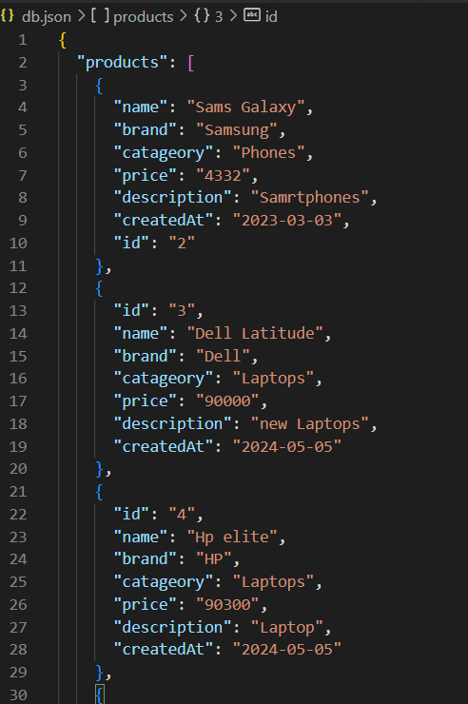

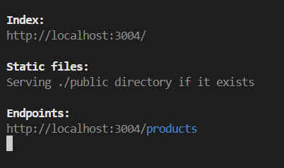

1. Your mock API will start running at “http://localhost:3000”.

